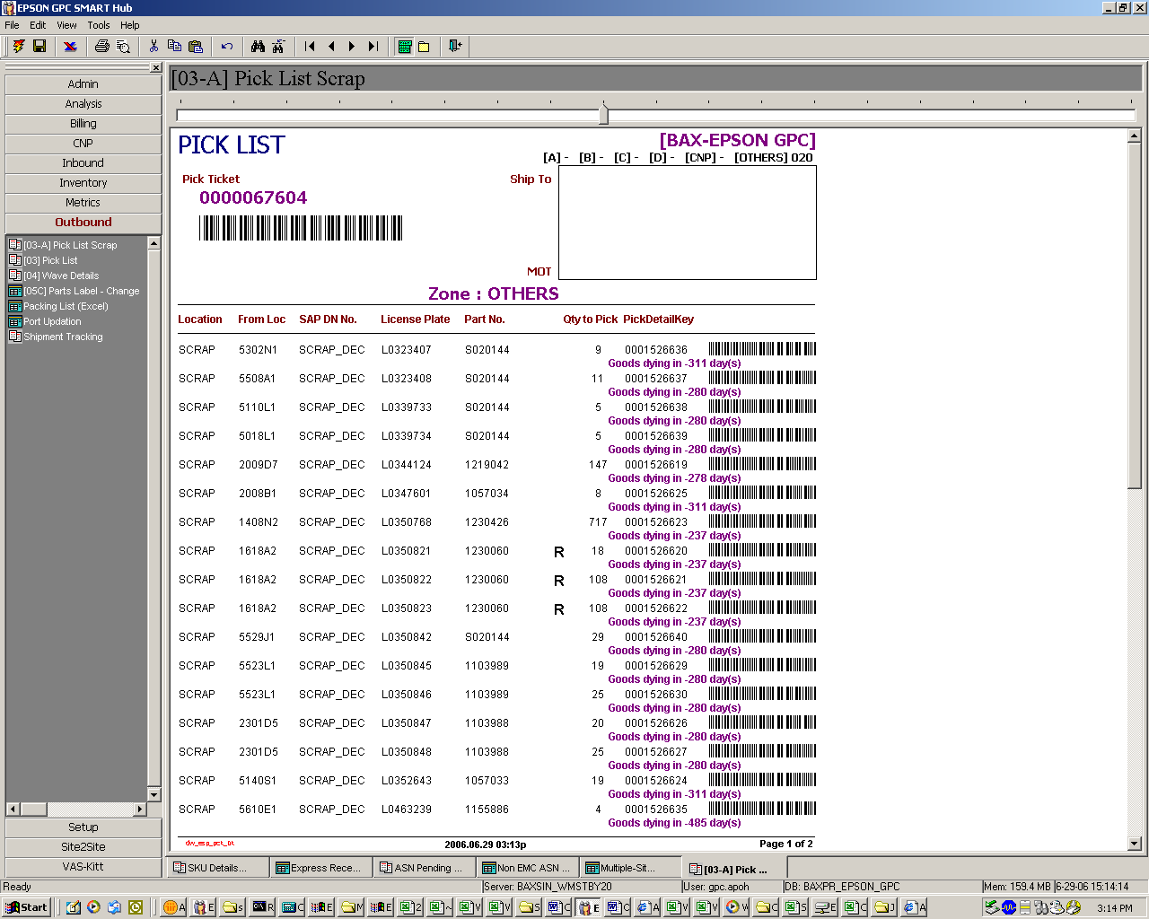
0
balal
Balance
Reflect the total qty left in the LP under sp01(for partial scrap)
E.g.
0 for whole LP scrap
6 for if the LP total 10pcs , 6 is in sp01, 4 on sp03

